

WA Sporting Car Club (Inc)
Supplementary Regulations
WASCC Racing Championship
Round 7 Night Masters Cup
MotorMall Wanneroo Raceway, Perth
Saturday 14th November 2026
Permit No: 626/1411/01

Administration

Regulations
- This WA Sporting Car Club (WASCC) Race Event will be held under the current:
  - FIA International Sporting Code including Appendices
  - Motorsport Australia Manual - National Competition Rules
  - Motorsport Australia Manual - Circuit Race Standing Regulations
  - Motorsport Australia WA State Circuit Racing Championship – Sporting and Series Regulations
  - 2026 WASCC Championships – Standing Regulations
  - Motorsport Australia Driving Standards Guidelines
  - These Supplementary Regulations and any amendments, Further Regulations, Event Bulletins.
- WASCC Events will be conducted under and in accordance with Motorsport Australia’s Occupational Health and Safety Policy, Integrity Policies, Legal Policies, Risk Management Policies, Safety 1st Framework, which can be found on the Motorsport Australia website at www.motorsport.org.au and any other relevant Policy.
- The Event known as WASCC Racing Championship Round 7 shall be a:

State Championship Circuit Race Event
  - Administration and Event Staff
- Event Promoter / Organiser: The WA Sporting Car Club (Inc)
Wattle Avenue East, NEERABUP WA 6031
- Phone: 08 9306 8022
- E-mail: evententry@wascc.asn.au
- Website: www.wascc.com.au
- Event Organising Committee: Chris Cheverall, Taylor Grant, Peter Morley,
John Hurney, Derek Burns, Gemma Clinton, Zoe Phillips, Matthew Newman and Matt Baker
- Organising Committee Address: PO Box 267 WANNEROO WA 6946
- Chief Steward: Paul Woolhouse
- Stewards: Tony Gard and Jenn Ellison
- Secretary of the Event: Gemma Clinton
- Assistant Event Secretary Zoe Phillips
- Clerk of the Course Matthew Newman
- Deputy Clerk of Course: Nathan Fenn
- Assistant Clerk of Course: Nathan Green
- Chief Scrutineer: John Najar
- Chief Timekeeper: Raymond Shaw
- DSA: TBA in Further Supplementary Regulations or Bulletin
- Chief Medical Officer (CMO): Dr Mohammed Ashfaq
r) Judges of Fact:
- Start: Matthew Newman, Nathan Fenn, Raymond Shaw & any further TBA via bulletin.
- Finish: Matthew Newman, Nathan Fenn, Raymond Shaw & any further TBA via bulletin.
- Lap Times, Records and Laps Completed: Raymond Shaw.
- Track Limits: Matthew Newman, Nathan Fenn & any further TBA via bulletin.
- Noise - dBA Level: TBA in Further Supplementary Regulations or Bulletin.
- Pit Lane Speed: TBA in Further Supplementary Regulations or Bulletin.
- Pit Entry Blend Line: TBA in Further Supplementary Regulations or Bulletin
- Pit Exit Blend Line: TBA in Further Supplementary Regulations or Bulletin

Medical
- The Medical Centre is located at the top of South Ramp, Near the Scrutineering Shed.
- The Medical Centre will be operational during the following times (AWST):
  - 14th November 12.00pm – 30 Minutes after the end of the last session.
- Any medical assistance that is required outside of the operating hours outlined in 1.3 (b) Please contact 000. The address to give to Emergency Services is: “Your Specific Location” E.g.: Garage 1, Motormall Wanneroo Raceway, entry via Wattle Ave, entry to the Raceway facility is via Gate 1.

Circuit Details
- Location: Wattle Avenue East, NEERABUP, WA 6031
- Length and Direction: Motormall Wanneroo Raceway Long Circuit: (FIA International Grade 3) 2.4150 kilometres – clockwise direction with asphalt surface.

Insurance
- Certain public, property, professional indemnity and personal accident insurance is provided by Motorsport Australia.
- Every entrant and driver must sign the Disclaimers and Entrants Statement on the Entry Form before taking part in any competition event. This shall include a statement attesting that the entered automobile conforms to its applicable eligibility criteria and is in a fit state for the proposed competition. Waivers and indemnities may be obtained using signage, tickets and on-line entry systems. Refer to motorsport.org.au for details on Motorsport Australia Disclaimer.

Official Sign-on and Briefing
Officials sign-on details will be communicated via email to all officials prior to the Event.

Entries
  - Drivers
    - Racing competitors must hold the minimum of a Motorsport Australia Circuit Licence with provisional endorsement. Those with a provisional endorsement must hand their licence passbook to the Clerk of the Course or Deputy Clerk and can be collected from the Race Control at the conclusion of the Event. All Drivers holding Provisional licences must have displayed a ‘P’ plate on the rear of their vehicle in accordance with Technical Appendix Schedule K.
    - For those non-member entrants, please ensure that you submit via email (zoe@wannerooraceway.com.au) a current copy of your Motorsport Australia affiliated club membership prior to entries closing 9th November at 9am.

Categories (and Classes) of Automobiles Admitted
Race: The competition will be conducted for the below categories of automobiles complying with the Categories of the Motorsport Australia Manual under Circuit Race and Historic appendices.
- 3E Excel Cup
- HQ Holdens
- 3E Production Cars
- Improved Production Cars
- Saloon Cars
- Historic Touring Cars
- WA Muscle Cars (3TA TransAm/3D Sports Sedans/Street Cars complying with 2026 WA Muscle Car regulations)
- Sports Cars
- Sports Sedans (including Street Cars)

Entry Lodgement
- Entries open on publication of these Supplementary Regulations.
- Entry forms are to be lodged via the WA Sporting Car Club online entry system www.wascc.com.au/raceentryform before the closing time and date of 9am Monday 9th November 2026.
- With the submission of their entry, the competitor(s) give their agreement, also on behalf of their driver(s), pit crew and sponsors, that the Organiser may record all activities in connection with the event and have them transmitted by radio, television, or other media. No claims against the Organiser or the transmission company may be raised.
- Attendance at the Race Office prior to the driver’s qualifying session is still necessary for those competitors who wish to add pit crew to their form.
- The Statement of Vehicle Compliance must be completed by all competitors by ticking the box via the WA Sporting Car Club entry portal.
  - Late Entries
    - Late entries will not be accepted.

Entry Fees
- Fees for entry are as follows:
  - Driver Racing Entry (WASCC Member) $346
  - Driver Racing Entry (Non-Member)/Associate WASCC Member $493
  - Carport Hire $47 payable with entry fee
  - Dorian Hire per car $29 payable with entry fee
- Please Note:
- All Entry Fees MUST be received on or prior to the closing date of entries of the Event.
- Ultimate membership covers your original entry fee of $346. If you are entering in a special round or a National, you will need to pay the difference.
- A competitor competing in multiple categories must enter both via the WA Sporting Car Club portal. To be considered eligible for a cross entry, two entry fees must be received.
- Any competitor who withdraws from a WASCC event prior to the event closing date will be entitled to a credit to their account.
Note: all credits will be processed within 5 working days after the completion of the Event.
- Any competitor whose withdrawal is received after the Event closing date but before the Event Briefing, will incur a $50 admin fee with the balance to be held in credit.
Note: if a WASCC member volunteers as an official for the Race Event, they shall have the full $50 admin fee credited into their account.
- No credit or other will be offered after commencement of the Drivers Briefing.
- Acceptance and Oversubscribed Entries:
  - Where the category entry list exceeds the track density for that category, entries shall be accepted based on order of receipt.
  - Competitors will be given the option to receive conditional acceptance and be placed on a reserve entry list if another competitor withdraws.
  - Competitors who do not accept this option will receive a credit of the entry fee paid.

Refusal of Entries
- The Organisers reserve the right to refuse entry in accordance with the NCR.
- The Organisers reserve the right to amalgamate category’s event in accordance with CRSR 2.2, the Motorsport Australia Stewards and the Motorsport Australia Safety Division (if applicable).

General
- Trailers, tow trucks and transporters are not to be parked in the paddock area, unless approval has been granted by WASCC.
- Loading and unloading of automobiles in the paddock areas must only be done before drivers’ briefing and after the last race of the day. Automobiles may be loaded prior to the last event in the trailer compound north of the Groundsman’s shed or south of the Arise Racing shed.
- Golf buggies (driven by people over the age of 16) and Feet ONLY are permitted in the paddock area.
No Scooters or Bikes.
- This Event may include a parade in accordance with the NCR.
- The official noticeboard is located within the Race Office and on Sportity.
- For electronic information for the WASCC Championship, download Sportity.
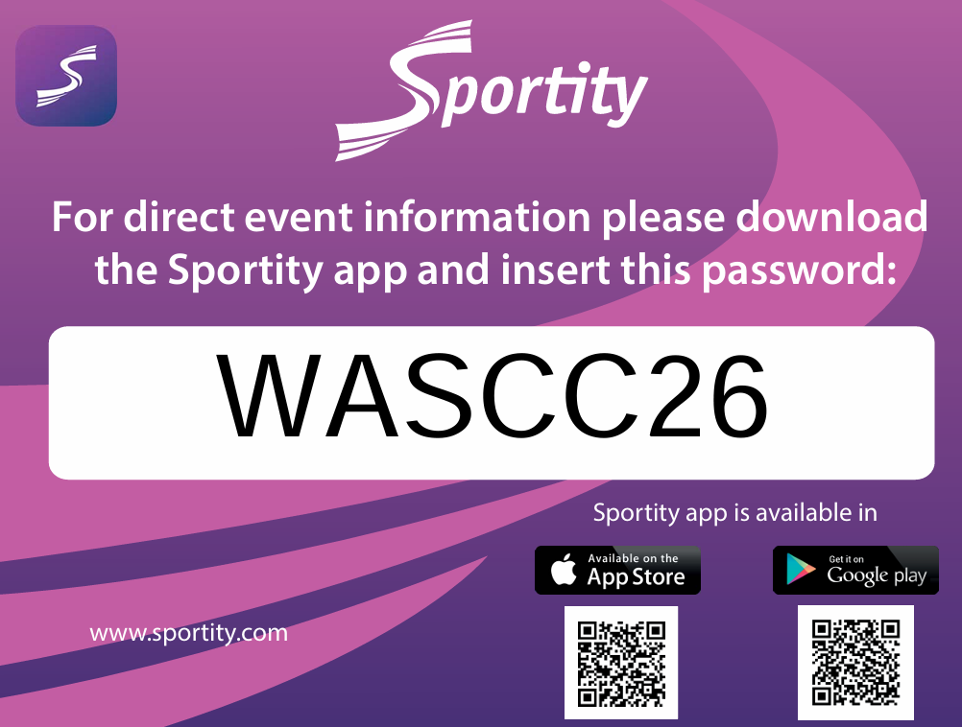

- Digital noticeboard will be used for all results via Sportity.
Note: Tuning Days are no longer included in Race Entry Fees.
- Results will be published via digital noticeboard provisionally throughout the event or at least 1 hour after completion, at https://wascc.com.au/results-grid-sheets/ or Sportity and final within 48 hours of the event.
g) For those using Raceceivers, they are to be tuned into Channel 001, 450.0000 Mhz.

Document Check
  - Competition Licence
- All Drivers will have their Motorsport Australia licences checked through the Motorsport Australia electronic platform.
- Drivers must comply to the Motorsport Australia General Appendix Licences document.

Driver’s Briefing
    - A time and place for the Drivers Briefing will be indicated on the timetable.

Automobile Log book Check
- All log books must be submitted to the category-labelled bucket located outside the scrutineering shed.
- At the conclusion of the Event, drivers or pit crew must retrieve the logbook from the scrutineering shed.

Scrutineering
  - Automobiles may be inspected at any time prior to or during the competition in accordance with the NCR.

Self-Extrication Requirements
    - Competitors may be required to perform a self-extrication test as per Motorsport Australia Self-Extraction Policy.
  - All Automobiles on Circuit after the official sunset time of 18:52, must have a minimum of one working head light (any colour except red) and a minimum of one tail-light operational.

Competition Procedures
  - Determination of Winner
- Points for each race shall be allocated to the driver for each race / trial as per the following table.

1st | 25 | 2nd | 20 | 3rd | 18 | 4th | 17 | 5th | 16
6th | 15 | 7th | 14 | 8th | 13 | 9th | 12 | 10th | 11
11th | 10 | 12th | 9 | 13th | 8 | 14th | 7 | 15th | 6
16th | 5 | 17th | 4 | 18th | 3 | 19th | 2 | 20th | 1

- The winner will be determined by the competitor with the highest accrued points on the day.
- In the event of a tie a comparison of results will determine the outcome with the final event result taking precedence.

Starting Procedures
- Unless stated elsewhere in these Regulations or Further Regulations all races will be non -championship standing starts.
- For a standing start one (1) crew member per car is permitted to remain on the pit wall to provide
directions to the driver until they come under starter’s orders.

- HQ Holdens
  - Race 3 of HQ Holdens to commence from a non-championship rolling start as per CRSR 5.5.
- Street Cars/Sports Cars/Sports Sedans and WA Muscle Cars: All races to commence from a non-championship rolling start as per CRSR 5.5 with the following modifications.
  - There will be two (2) formation laps, on the second formation lap each vehicle must form up into a 2x2 formation between Marshall Post 6.5 and 6.7 (where the short circuit re-joins the track), accelerating, braking, and moving left or right must cease beyond Marshall Post 6.7.
- Saloon Cars: All races to commence from a non-championship rolling start as per CRSR 5.5.

Flags & Light Signalling
    - For the duration of the Event, Flags and/or Light panels will be used for supervision and advisory purposes. Flag and trackside light panels are regulatory.
    - Last Lap Board is to be shown for all races in the race sessions. NOTE: an inadvertent omission to show the Last Lap Board will under no circumstances constitute any race being declared a “no race” or to be permitted to form the basis of any protest.

Grid Positions
    - Unless stated elsewhere in these Regulations or Further Regulations all grid positions will be:
      - First race – from qualifying times, with the fastest qualifier to pole.
      - Second race – on the finishing order from Race 1.
      - Third race – on the finishing order from Race 2.

    - 3E Excel Cup
      - First race – from qualifying times, with the fastest qualifier to pole
      - Second race – on the finishing order from Race 1
      - Third race – will be determined by combining the points from Race 1 and Race 2, with the highest points scorer advancing to the pole.

Event Lengths
Race lengths for each category will be as follows, with the time commencing at the display of the green flag at pit exit. Unless stated elsewhere in these regulations or Further Regulations, race lengths for ALL categories will be:
CATEGORY | RACE 1 | RACE 2 | RACE 3
3E EXCEL CUP | 12 MINUTES + 1 LAP | 15 MINUTES + 1 LAP | 12 MINUTES + 1 LAP
IMPROVED PROUCTION CARS & 3E PRODUCTION CARS | 12 MINUTES + 1 LAP | 15 MINUTES + 1 LAP | 12 MINUTES + 1 LAP
HQ HOLDENS | 12 MINUTES + 1 LAP | 15 MINUTES + 1 LAP | 12 MINUTES + 1 LAP
SALOON CARS | 12 MINUTES + 1 LAP | 15 MINUTES + 1 LAP | 12 MINUTES + 1 LAP
SPORTS CARS, SPORTS SEDANS, STREET CARS & WA MUSCLE CARS | 12 MINUTES + 1 LAP | 15 MINUTES + 1 LAP | 12 MINUTES + 1 LAP
HISTORIC TOURING CARS | 12 MINUTES + 1 LAP | 15 MINUTES + 1 LAP | 12 MINUTES + 1 LAP

Timing
- The Organisers utilise an automatic timing system that requires all cars to be fitted with a Dorian Data-1 transmitter, which is the Competitor’s responsibility to be fitted correctly for all sessions.

Trophies
Trophies may be presented at the completion of the Event.
- Trophies will be awarded as follows:
  - Minimum 3 driver field = 1st place trophy only.
  - Minimum 6 driver field = 1st and 2nd place trophies.
  - Minimum 9 driver field = 1st, 2nd, 3rd place trophies.
- Trophies will be awarded as per Category Request forms submitted to the CEC by Category Representatives prior to the commencement of the season.

Pit Lane & Paddock
- The paddock area is defined as any non-competition area within the facility.
- The speed limit within the Paddock area is 15kph.
- The Pit Lane speed limit is 40kph.

Parc Fermé
Parc Fermé will be in the scrutineering area at the south end of the paddock area.

Protests
Any Protests must be lodged in accordance with the NCR.

Integrity
Motorsport Australia’s National Integrity Framework and relevant Integrity Policies, including the Australian Anti-Doping Policy, Illicit Drugs in Sport (Safety Testing) Policy, and the Alcohol Policy apply to any activity authorised sanctioned by Motorsport Australia.
Any Participant including the holder of a Motorsport Australia Licence (or a Licence issued by another ASN) may be tested for the presence of alcohol, any drug or other banned substance. In addition to any penalty imposed by Motorsport Australia, a further penalty/s may be applied by Sport Integrity Australia.

Postponement or Cancellations of a Competition
The Organiser reserves the right to postpone or cancel an Event in accordance with the NCR.

Smoking
Motormall Wanneroo Raceway has strict ‘no-smoking’ areas in accordance with WA statutes and designated areas including the Paddock and pit areas.
Smoking including e-cigarettes, vaping and any naked flame is prohibited within 3 metres of
any refuelling or de-fuelling operation.

Social Media
All participants are subject to:
- The WASCC Social Media Policy (can be found on the WA Sporting Car Club website)
- The Motorsport Australia Social Media Policy (can be found on the Motorsport Australia website).

Camping

If you require camping for the duration of the Event, please contact Zoe (zoe@wannerooraceway.com.au) or the WASCC administration office 08 9306 8022 prior to 5pm Thursday 12th November 2026.

